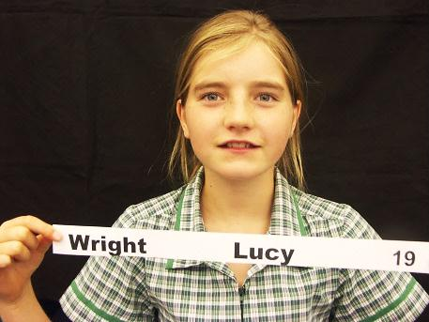
Lucy Wright
Room 19 HNI
Havelock North
March 14, 2012
Dear Miss Pullar,
I am writing you this email to ask you if you would kindly review my Yola webpage and tell me what you think of it and what I can improve. This is a list of the basic evaluation criteria:
. Layout
. Legible
. Pictures
. Colours
. Spelling
. Punctuation
. Grammar
. Appealing to the eye
. And of course the content of what’s on it

My webpage will also be reviewed by my teacher Mr. Stove, my parents, a kid from my class, another student from my school and hopefully you.
I have spent a lot of time working on my Yola and I really hope you like it.

This is the link http://lucyw.yolasite.com

Thank you for your time

Yours sincerely,

Lucy Wright

